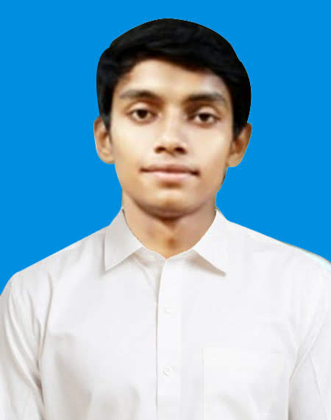

Travel

**🌏🏠**

**🎜**

**🛪🏠🏠**

On the Insert tab, the galleries include items that are designed to coordinate with the overall look of your document.

On the Insert tab, the galleries include items that are designed to coordinate with the overall look of your document.

2014 - 2016

On the Insert tab, the galleries include items that are designed to coordinate with the overall look of your document.

**EXPERIENCE**

**SKILLS**

**EDUCATION**

Twiter @Md.faisal linkedIn@ Md.faisal Beacnce: Md.faisal

**C++**

**Html**

**HOBBIES**

**CONTACT**

**PROFILE**

***Art Director***

**MD. FAISAL****ISAL**

UNIVERSITY OF YK

On the Insert tab, the galleries include items that are designed to coordinate with the overall look of your document.

You can use these galleries to insert tables, headers, footers, lists, cover pages, and other document building blocks.

When you create pictures, charts, or diagrams, they also coordinate with your current document look.

* Point 1
* Point 2
* Point 3
* Bachelor in Visual Desing

2011 - 2014

* Masters in Visual Desing

UNIVERSITY OF kd

On the Insert tab, the galleries include items that are designed to coordinate with the overall look of your document.

* Masters in Visual Desing

DUGAB YK DESING CO

Mdfaisal521@outlook.com

**🖂**

2015 - 2016

+62 06 19090

**✆**

TATO SINGO .INC

* Masters in Visual Desing

**🏠🏠🏠**

2014 - 2016

Merkid,Yeayakaraayogayaka

www.md.faisal.com

**Unity**

Reading

**🕮**

Writing

**Python**

**C#**

**🖉**

Travel

**JavaScript**